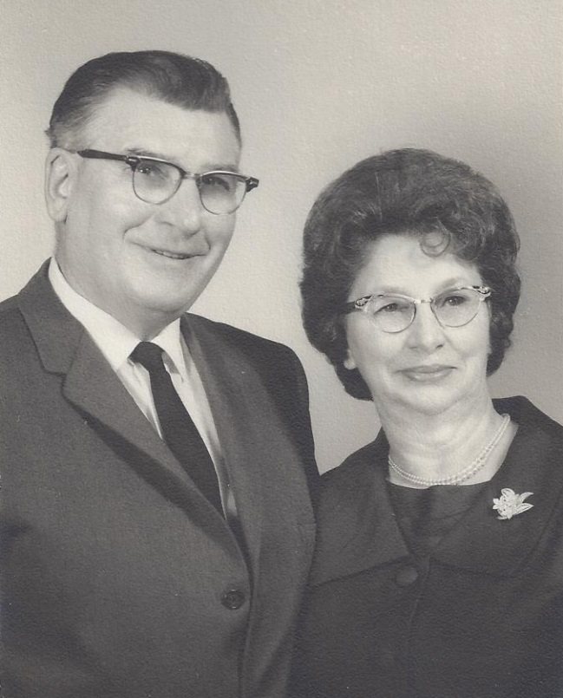

Russell & Mary Foster Wolfe - 7 Mar 1968

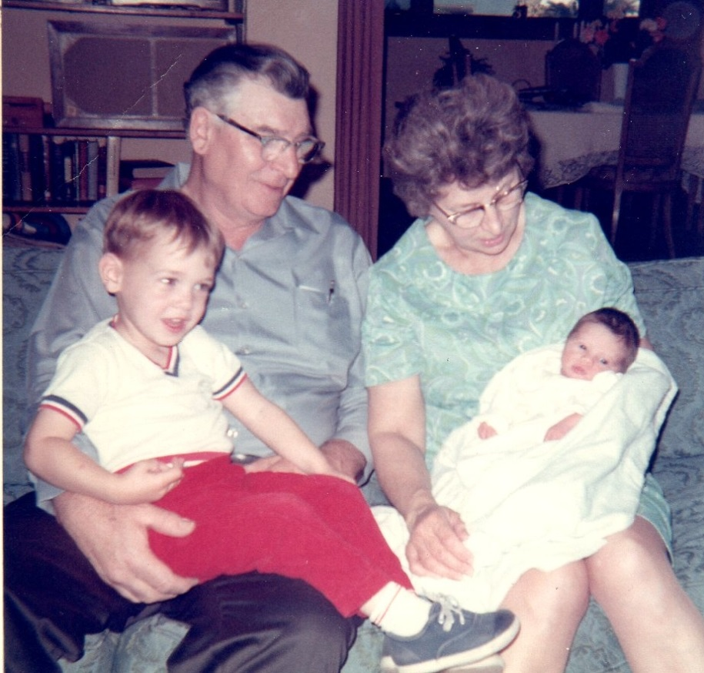

Russell & Mary Wolfe, Brian & Elaine Moore - 1969